**Help Documents:**

Help Documents compile a repository of helpful documents, guides, and tutorials.

Cover topics such as study tips, time management, and effective learning strategies.

Include downloadable resources and links to external guides.

**1. Study Tips for Dental Students:**

Dental school demands a unique set of study skills due to its combination of theoretical learning and hands-on clinical practice. This document delves into specific study techniques, including active learning methods, group study sessions, and utilizing technology for interactive learning. It emphasizes the importance of creating a structured study schedule and maintaining a healthy work-life balance to foster long-term success.

External Link: [Effective Study Techniques for Dental Students](https://www.dentistrytoday.com/news/todays-dental-news/item/555-effective-study-techniques-for-dental-students)

<https://www.studentdoctor.net/about-sdn/quick-guide-to-sdn-resources/#h-pre-dental-and-dental-students>



**2. Time Management in Dental School:**

Managing time effectively is a critical skill for dental students juggling lectures, laboratory work, and clinical rotations. This guide delves into practical time-management strategies, such as creating daily and weekly schedules, setting priorities, and using productivity tools. It also addresses the importance of self-care and stress management to ensure students maintain their well-being throughout their dental education journey.

External Link: [Time Management Strategies for Dental Students](https://www.adea.org/uploadedFiles/GoDental/Tips_for_Getting_Into_Dental_School/Time%20Management%20Strategies%20for%20Dental%20Students.pdf)

[https://www.colgateprofessional.com/students-faculty/trending-topics/time-management-tips-for-dental-students#](https://www.colgateprofessional.com/students-faculty/trending-topics/time-management-tips-for-dental-students)



**3. Innovative Pedagogical Strategies for Dental Procedures:**

Mastering dental procedures involves a combination of theoretical understanding and practical application. This resource offers in-depth insights into different learning strategies, such as utilizing dental simulators, engaging in hands-on workshops, and participating in case-based discussions. It encourages students to seek mentorship and clinical experiences to enhance their skills and build confidence in performing procedures.

**PDF Link:** <https://cms.galenos.com.tr/Uploads/Article_44735/GMJ-63-8-En.pdf>

External Link: Innovative Pedagogical Strategies

<https://www.mdpi.com/1660-4601/20/3/2041>



**4. Oral Health Research Guides:**

Research is the backbone of advancements in dentistry. This guide provides an extensive list of databases, journals, and organizations where students and professionals can access the latest research in areas such as preventive dentistry, oral pathology, and dental technology. It emphasizes the importance of staying informed to contribute to evidence-based practice.

External Link: [National Institute of Dental and Craniofacial Research](https://www.nidcr.nih.gov/)

<https://www.nidcr.nih.gov/>

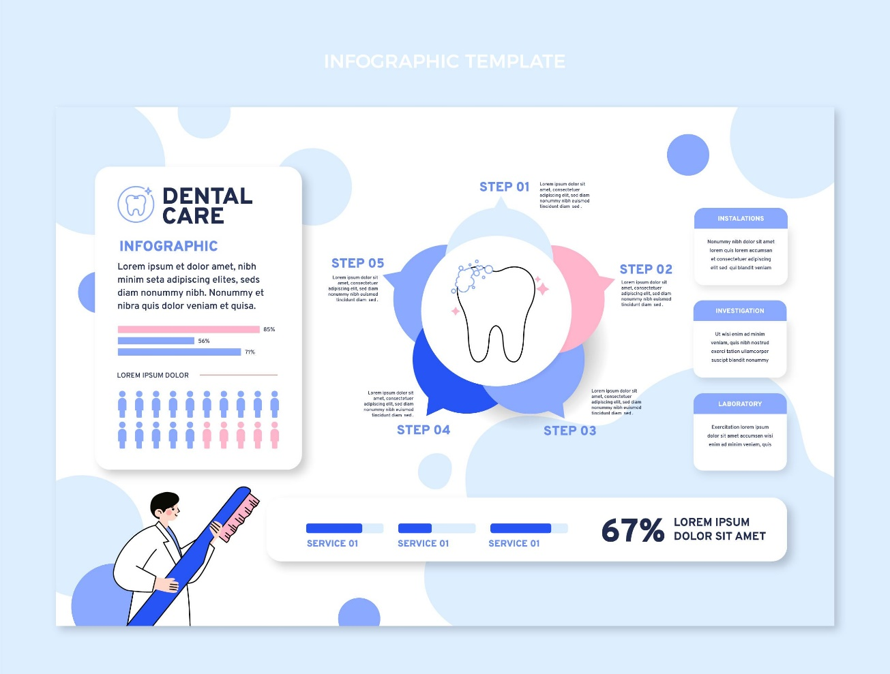

**5. Dental Anatomy and Terminology:**

Understanding dental anatomy is foundational for dental professionals. This section includes detailed tutorials on tooth morphology, oral structures, and terminology commonly used in dental practice. It may incorporate interactive 3D models or diagrams to facilitate a comprehensive understanding of dental anatomy.

External Link: [Dental Anatomy Basics](https://www.kenhub.com/en/start/dental-anatomy)

<https://www.vcdental.com.au/tooth-anatomy-education/#:~:text=Root%20and%20Neck%3A-,The%20tooth%20has%20two%20anatomical%20parts%2C%20the%20crown%20and%20the,the%20tooth%20in%20the%20mouth>.

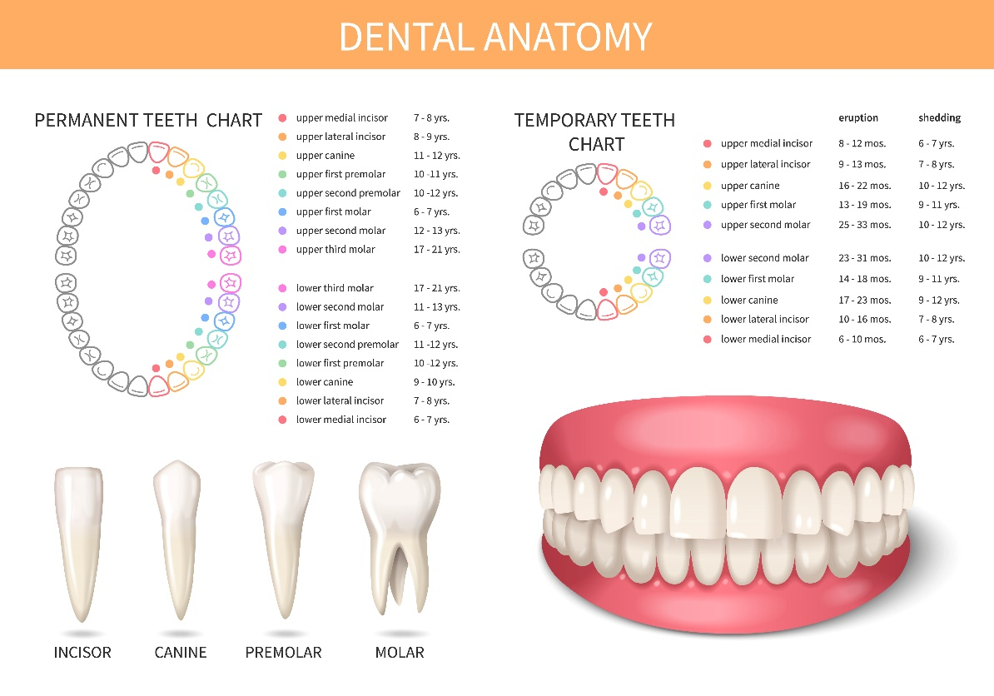

**6. Clinical Case Studies:**

Real-world scenarios offer invaluable learning opportunities. This portion of the repository features a diverse collection of clinical case studies, each detailing patient histories, diagnostic processes, and treatment plans. It encourages students to critically analyze cases, discuss possible approaches, and consider the ethical implications of different treatment options.

External Link: [Dental Clinical Cases](https://www.dentistrytoday.com/cced)

<https://dentalblog.3m.com/dental/category/clinical-cases/>



**7. Patient Communication and Ethics:**

Effective communication is key to building trust with patients. This guide not only explores the ethical considerations in patient communication but also provides practical tips on delivering difficult news, obtaining informed consent, and maintaining patient confidentiality. It highlights the significance of empathy and cultural competence in fostering positive dentist-patient relationships.

External Link: [Ethical Guidelines for Patient Communication](https://www.ncbi.nlm.nih.gov/pmc/articles/PMC3399557/)

<https://www.unicorndenmart.com/ethics-in-dentistry-upholding-professional-standards/>

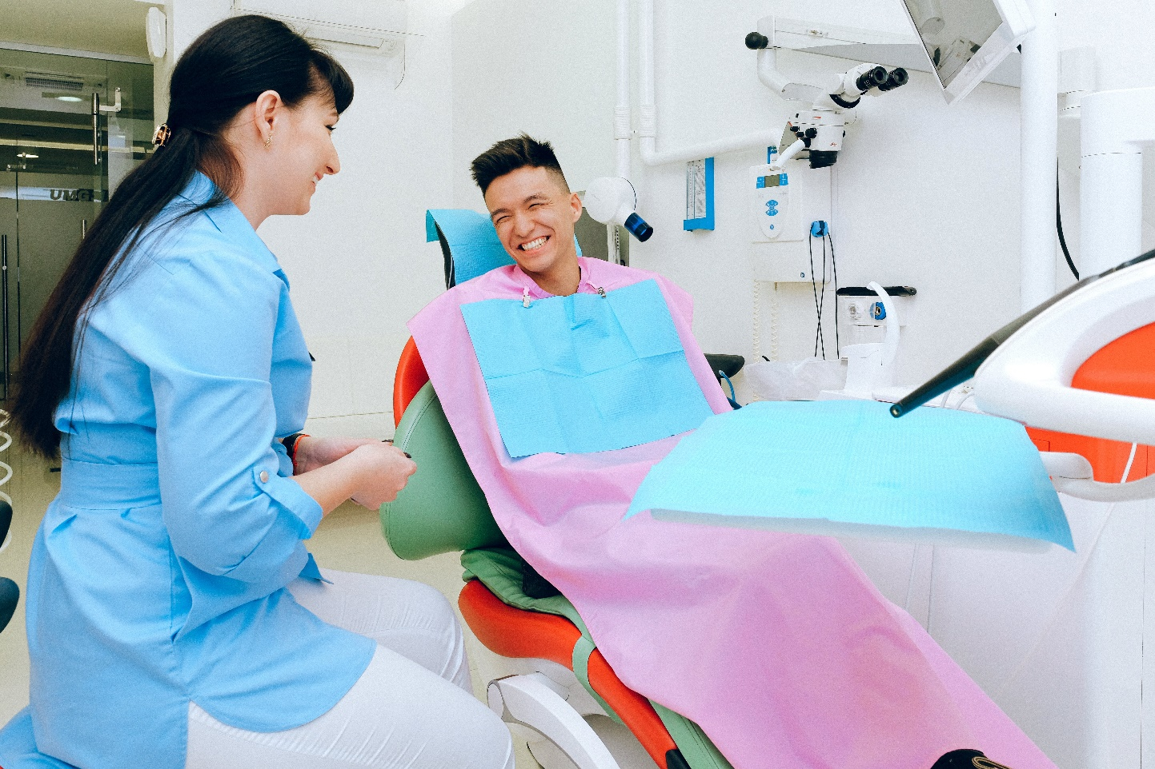

**8. Dental Practice Management:**

Running a successful dental practice involves a multifaceted approach. This section offers detailed insights into practice management, covering topics such as financial planning, marketing strategies, staff training, and compliance with industry regulations. It may include case studies of successful dental practices as practical examples.

External Link: <https://www.ada.org/en/resources/practice/practice-management>



**9. Dental Technology Guides:**

Embracing technological advancements is crucial in modern dentistry. This resource provides comprehensive guides on the latest dental technologies, including digital radiography, CAD/CAM systems, and teledentistry. It may offer step-by-step tutorials on integrating these technologies into daily practice for improved patient care and practice efficiency.

External Link: [Dental Technology Guide](https://www.dentistrytoday.com/technology)

<https://www.yourdentistryguide.com/dental-technologies/>



**10. Continuing Education Resources:**

Lifelong learning is a cornerstone of professional growth. This section not only lists reputable platforms for continuing education but also guides professionals on developing a personalized learning plan. It emphasizes the importance of staying informed about changes in dental regulations, emerging technologies, and evolving treatment modalities to provide the highest standard of care to patients.

External Link: [ADA Continuing Education](https://www.ada.org/en/education-careers/continuing-education)

<https://www.ada.org/en/education/continuing-education>

